
GIS Library Tutorials – Introduction to ArcGIS Online - 9

Joining two files and visualising numerical data
ArcGIS Online cannot use spreadsheets which are in Excel format, e.g. xls or xlxs – so if you have an Excel spreadsheet you will need to save it as a .csv file first in order to use it in ArcGIS Online
In this exercise we will visualise data from Pobal available on this website http://trutzhaase.eu/deprivation-index/the-2016-pobal-hp-deprivation-index-for-small-areas/
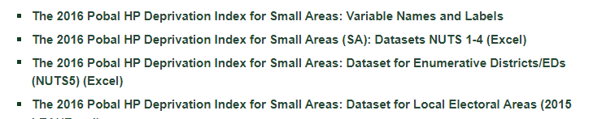
The 2016 Pobal HP Deprivation Index shows the level of overall affluence and deprivation at the level of electoral division.

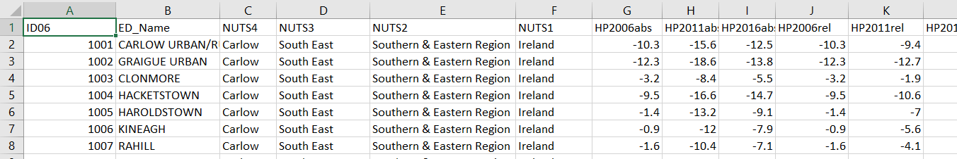

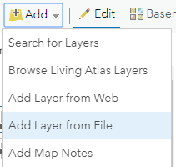
Left click on the Add button
From the menu which opens left click on Add Layer from File

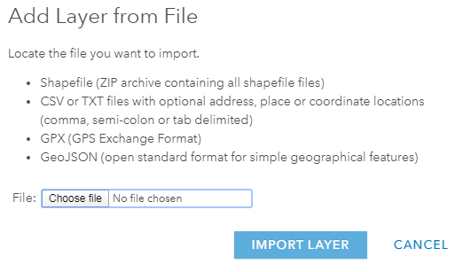
Left click on Choose file

Navigate to the folder where your Pobal csv file is located
Left click on Pobal Deprivation 2016_Wicklow.csv and left click on Open
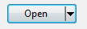

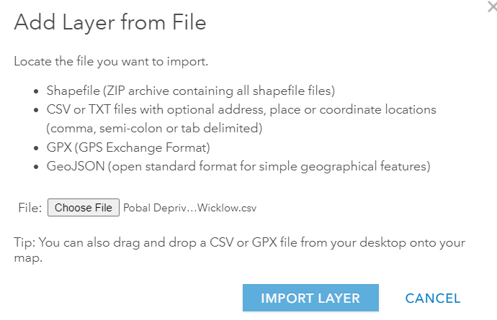
The selected file will now be attached
Left click on IMPORT LAYER

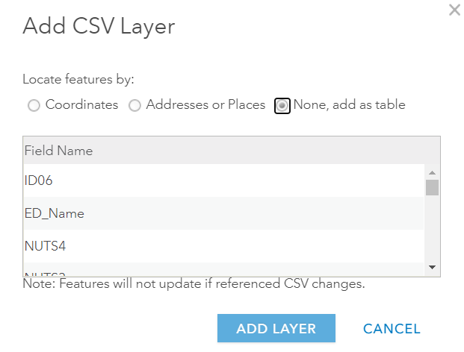
Left click on the radio button next to None, add as table

Left click on ADD LAYER
The Pobal csv file will now be the last layer visible in the Content section –
Left click in the checkbox for the Electoral Divisions to make the layer visible on the map

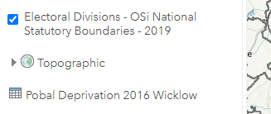

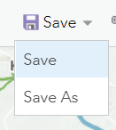
Left click on the Save icon and then click on Save

Joining Pobal table to the OSi data so that the deprivation data is visualised by ED areas
Before starting, ensure you can see the entire county of Wicklow on the map

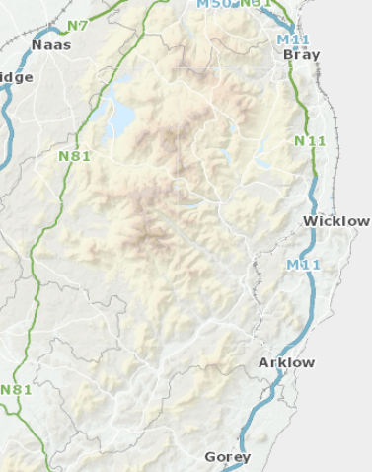
Before starting, ensure you can see the entire county of Wicklow on the map

The Column names are different, but the CONTENT is identical
The content MUST be identical for the join to work…

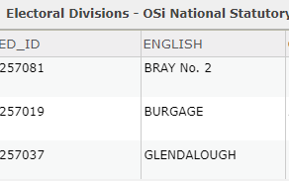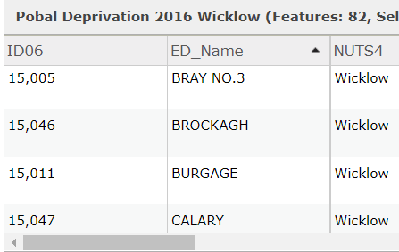

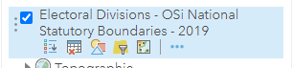
Hover over the Electoral Divisions layer and left click on the Perform Analysis tool

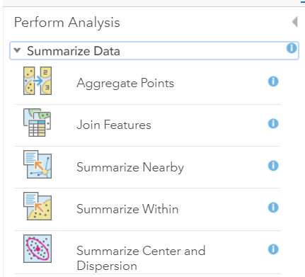
Left click on the Summarize Data option, then left click on Join Features

The Target Layer (Electoral Divisions) is the layer that the related records are attached to.
The Layer to Join to the Target Layer (Pobal Deprivation) are the related records that will be symbolised.
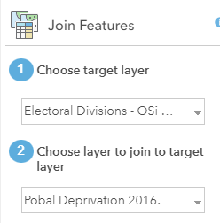
In Choose target layer the file to select with the pull-down arrow is the Electoral Divisions layer
In Choose layer to join to target layer the file to select with the pull-down arrow is the Pobal Deprivation file

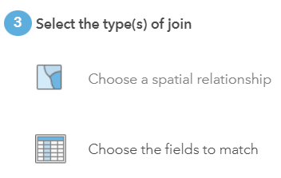
We are using Choose Fields to match because the Pobal file is a spreadsheet not a spatial format such as a polygon, shapefile or point data type

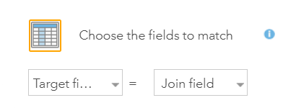
Left click on Choose the fields to match and use the pull-down arrow to find and left click on English and in the other box ED_Name

The Target Field = ENGLISH
The Join Field = ED_Name

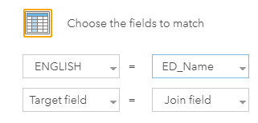
The Column names are different, but the CONTENT is identical
The content MUST be identical for the join to work…

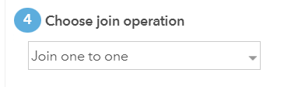
Left click on Join one to one

A unique name in the ENGLISH column of the Electoral Divisions data will be matched with the same unique name in the ED_Name column of the Pobal Deprivation csv file.

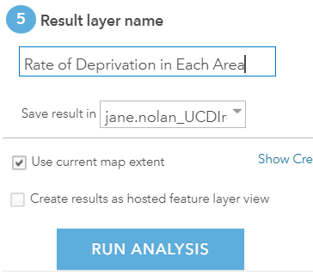
Name your layer
Left click in the Use current map extent checkbox
Left click on RUN ANALYSIS

Wicklow

The new layer will appear in your Contents list and on the map, left click on Change Style 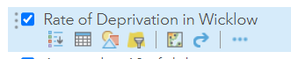
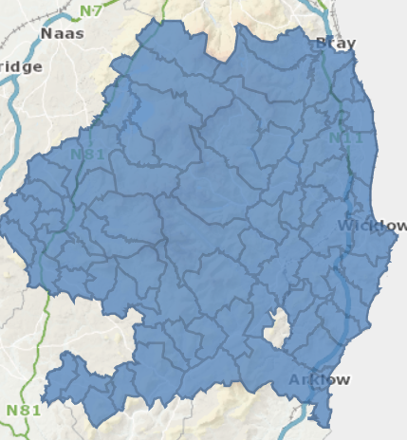
Why is this area blank?
In the Electoral Divisions file this is named Ovoca
In the Pobal Deprivation data it is named Avoca
Therefore, because the names are not identical there was no join made

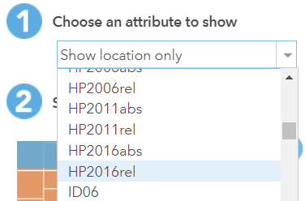
Left click at the arrow below Choose an attribute to show and scroll down – left click to choose HP2016rel

This field gives values of affluence and deprivation relative to the national average

As this is a field with values, you will see two options to visualise your data – Counts and Amounts by Size and also Counts and Amounts (Colour)

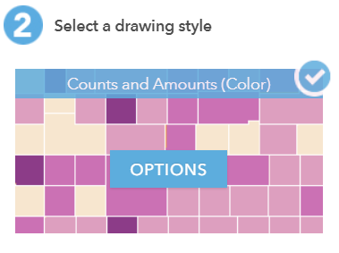
At Counts and Amounts (Colour)
left click on OPTIONS
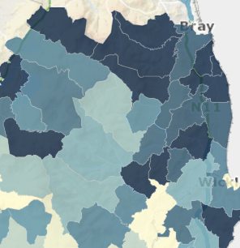
The data will be applied as a colour range within the Electoral Division administrative boundary areas.
This is a choropleth map – values are represented by shades of colour

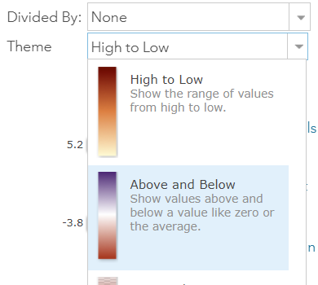
In the Theme field left click on the down arrow to change the way the data is represented, e.g., change to Above and Below

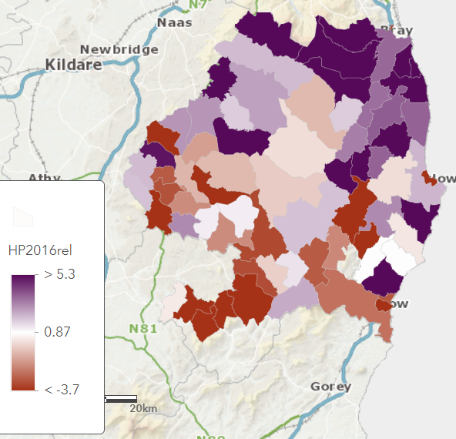
Darkest purple are the most affluent areas, and darkest brown are the areas of highest deprivation – relative to the national average.

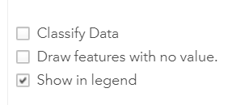
To show a larger number / or lesser number of classes, left click in the checkbox for Classify Data so that a tick appears
Good practice is usually between five and seven groups. There are enough groups to distinguish between colours, but not so many that it’s difficult to tell different colours apart.

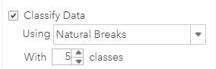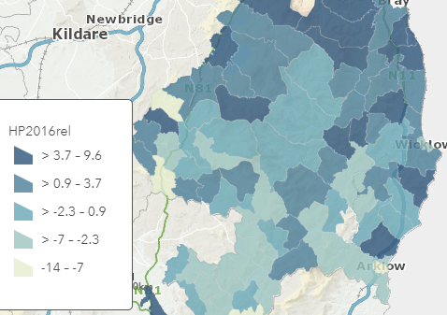
To see how the map changes, increase the number of classes to 5
Left click on the Symbols icon to change the colour ramp

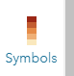
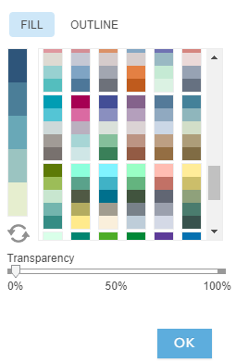
You could choose a colour ramp which has dark colours at the extremes of the data, e.g., most affluent, most deprived
or you could choose a colour ramp which graduates from light to dark
Left click on OK

Left click on OK

Left click on DONE
Left click on the Save icon and left click on Save

